
TDHCA Outreach and Media Analysis,
November 2024

A compilation of TDHCA media analysis designed to enhance the awareness of TDHCA programs and services among key stakeholder groups and the general public, and outreach activities, such as trainings and webinars. The following is an analysis of print, online and broadcast news, and social media reporting for the time period of November 1-30, 2024 (news articles that specifically mentioned TDHCA generally or along with Department programs).

Total number of articles referencing TDHCA: 21
Breakdown by Medium:
- Print: 4 (Editorials/Columnists = 0)
- Broadcast: 1
- Trade, Government or Internet-Based Publications: 16

Figure 1 News Tone

Figure 2 News Topic

Figure 3 Media Market

Summary:
Reporting on TDHCA activities by the news media totaled 21 references in November 2024. References related to development projects across Texas financed through TDHCA’s Housing Tax Credit Programs dominated the news cycle.

News mentions during the month were slightly lower than November 2023 (29 total).
The following table illustrates the number of news mentions during each month or quarter of 2024 compared to 2023 and 2022. For the first two months of the fourth quarter of 2024 (October-November), total news mentions are tracking close (65 total) compared to the number of mentions during the same timeframe of 2023 (67 total), but lower than 2022 (346 total). Please note, some pandemic-related programs for which TDHCA had oversight were still operating and accepting applications the previous two years.

Social media:
Through November 2024, TDHCA has nearly 3,700 followers to its X (formerly known as Twitter) account and 7,630 fans to its Facebook page. TDHCA’s YouTube channel had 4,065 views in October. The following is a summary analysis of TDHCA’s efforts to inform stakeholders and the public on federal and state resources, initiatives, and programs.


Month/Yr | Posts | Clicks | Engagements | Shared posts | Reactions
January 2024 | 13 | 19 | 27 | 3 | 20
February 2024 | 50 | 0 | 29 | 3 | 23
March 2024 | 51 | 7 | 14 | 3 | 11
April 2024 | 67 | 8 | 5 | 2 | 75
May 2024 | 48 | 14 | Approx. 136 | 43 | 93
June 2024 | 66 | 0 | Approx. 109 | 12 | 97
July 2024 | 112 | 0 (no longer supported)* | Approx. 347 | 137 | 191
August 2024 | 16 | 0 (no longer supported)* | Approx. 32 | 4 | 23
Sept. 2024 | 53 | 0 (no longer supported)* | Approx. 61 | 1 | 58
Oct. 2024 | 70 | 0 (no longer supported)* | Approx. 96 | 5 | 85
Nov. 2024 | 71 | 0 (no longer supported)* | Approx. 78 | 1 | 76
* Clicks = number of times an individual clicked on a link provided in a post; however, FB only tracks clicks for posts that reach a minimum engagement level of 30. Engagements = any action a person takes on our post including shares, comments and reactions.


Month/Yr | Tweets | Clicks | Engagements | Retweets | Liked posts
January 2024 | 15 | 8 | 14 | 5 | 7
February 2024 | 52 | 12 | 15 | 2 | 10
March 2024 | 52 | 3 | 14 | 1 | 9
April 2024 | 67 | 1 | 14 | 2 | 11
May 2024 | 49 | 16 | 18 | 5 | 12
June 2024 | 63 | 0 | 58 | 57 | 1
July 2024 | 114 | 3 | 48 | 9 | 32
August 2024 | 17 | 0 | 7 | 0 | 3
Sept. 2024 | 53 | 16 | 5 | 2 | 2
Oct. 2024 | 79 | 0 | 40 | 7 | 26
Nov. 2024 | 71 | 10 | 4 | 0 | 3
* Clicks = number of times an individual clicked on a link provided in a post. Engagements = any action a person takes on our post


Month | Views | Watch time (hours) | Avg. view duration | Avg. % viewed | Unique viewers
January 2024 | 9,988 | 909.4 | 5:27 | 14.9% | 8,076
February 2024 | 7,234 | 572.3 | 4:44 | 14.8% | 5,849
March 2024 | 6,733 | 490.1 | 4:22 | 13.4% | 5,598
April 2024 | 6,058 | 500.4 | 4:57 | 16.0% | 5,047
May 2024 | 5,720 | 440.5 | 4:37 | 14.1% | 4,700
June 2024 | 5,426 | 439.5 | 4:51 | 15.1% | 4,415
July 2024 | 5,754 | 470.1 | 4:54 | 16.3% | 4,798
August 2024 | 7,395 | 664.9 | 5:23 | 17.4% | 6,095
Sept. 2024 | 5,639 | 473.9 | 5:02 | 15.7% | 4,565
Oct. 2024 | 6,706 | 536.2 | 4:47 | 16.0% | 5,552
Nov. 2024 | 4,065 | 364.8 | 5:23 | 15.4% | 3,339

Understanding the YouTube Analytics
- Views: number of times your videos were viewed
- Watch Time: total number of hours your videos were watched by viewers
- Average View Duration: total watch time of your video divided by the total number of video plays, including replays. This metric measures your video’s ability to engage viewers. The higher the view duration, the more engaging the videos.
- Average Pct Viewed: the percent of each video the average viewer watched. It measures your video’s ability to hold viewers’ attention for its entirety. YouTube generally rewards videos that can hold people’s attention with higher search and recommendation rankings.
- Unique viewers: the estimated number of individuals who watch your videos over a certain period of time. It helps determine the size of our audience.

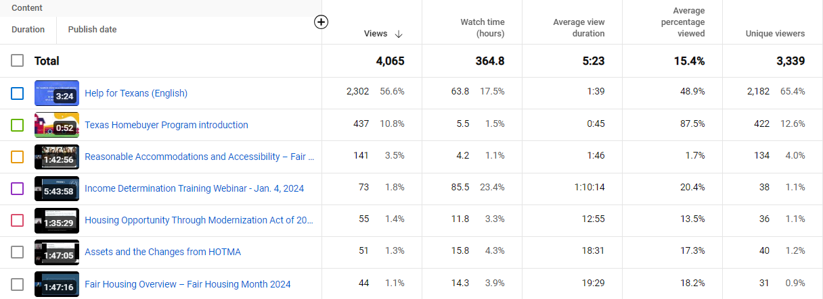
Top 25 videos for November 2024

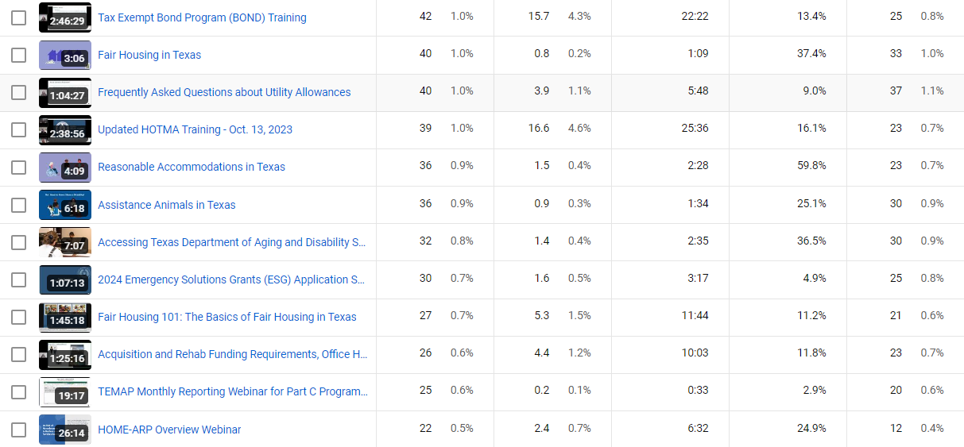

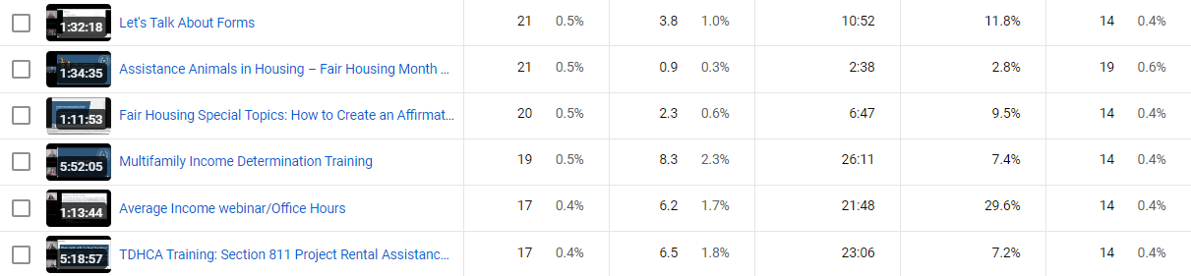

TDHCA Outreach November 2024
A compilation of outreach activities such as meetings, trainings and webinars.

Department | Meeting Date | Meeting Title | Attendees (includes organizer)
Community Affairs/CSBG | Nov. 4 | Virtual Training Session/Reentry Sub | 15
Community Affairs/CSBG | Nov. 4 | Onsite Training Session/TCCAA | 10
Community Affairs/WAP | Nov. 5 | Virtual Training Session/Multiple Subs | 10
Community Affairs/CSBG | Nov. 5 | Onsite Training Session/TCCAA | 10
Community Affairs/WAP | Nov. 5 | Virtual Training Session/Multiple Subs | 13
Community Affairs/WAP | Nov. 6 | Virtual Training Session/Multiple Subs | 15
Housing Resource Center | Nov. 12 | Fair Housing Webinar/Fair Housing Overview | 330
Compliance | Nov. 12 | MFDL training with the Texas Apartment Association | 55
Housing Resource Center | Nov. 14 | Fair Housing Webinar/Reasonable Accommodations | 212
Community Affairs/CSBG | Nov. 19 | Onsite Training Session/GCCSA | 10
Housing Resource Center | Nov. 19 | Fair Housing Webinar/Assistance Animals | 176
Community Affairs/CSBG | Nov. 20 | Onsite Training Session/GCCSA | 10
Compliance | Nov. 22 | Office Hours and Acquisition/Rehab and Re-Syndication training | 108

Broadcast numbers may represent times in which TDHCA was referenced on a television or radio station’s website, rather than in a broadcast segment. 2 News Topics: Programs include Housing Tax Credit.

